**PROJECT Bank account simulator program 100 points**

**Objective** To write a program that performs various bank transactions.

**PROJECT DESCRIPTION**

Bank of IIT has contacted you to write, compile and execute a complete program that creates bank account information and executes various transaction details for their clients.

Your program will prompt users for options such as creating an initial balance, entering deposits or withdrawals. Also, your program will allow for the printing of account information including interest at various interest rates.

Use loops, user defined methods, conditional and relational logic and the basics of OOP to accomplish the objectives of this program.

Error trapping will be part of your grade so don’t forget to include some basic error trapping logic! Comment your code thoroughly as well for maximum points.

**Snapshots of Testcases:**

1. Prompt for initial deposit

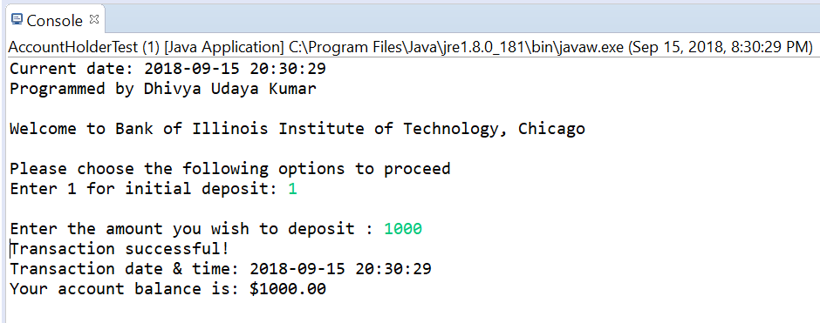

1. Initial Deposit (Throw error if invalid amount is entered)

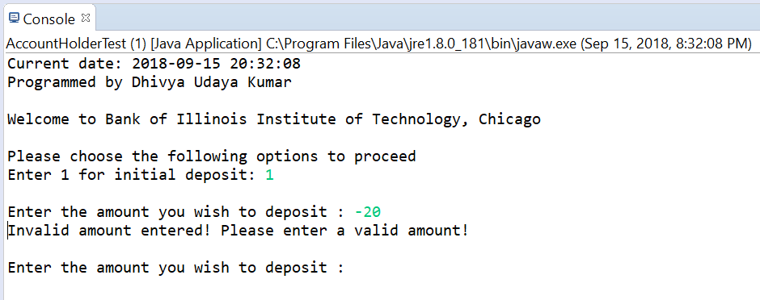

1. Prompt user to select an option from the menu

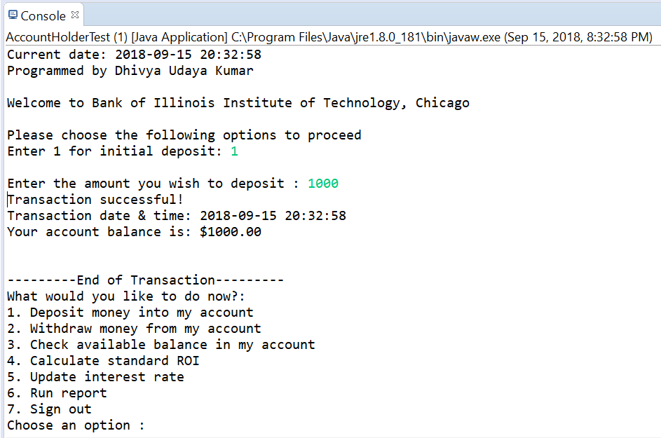

1. Prompt user to withdraw (Successful withdrawal scenario)

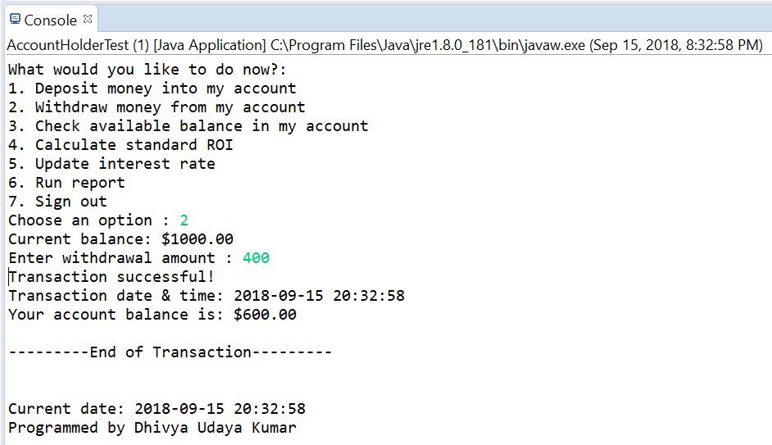

1. Prompt user to withdraw (Unsuccessful withdrawal scenario – Account balance should not go below $100)

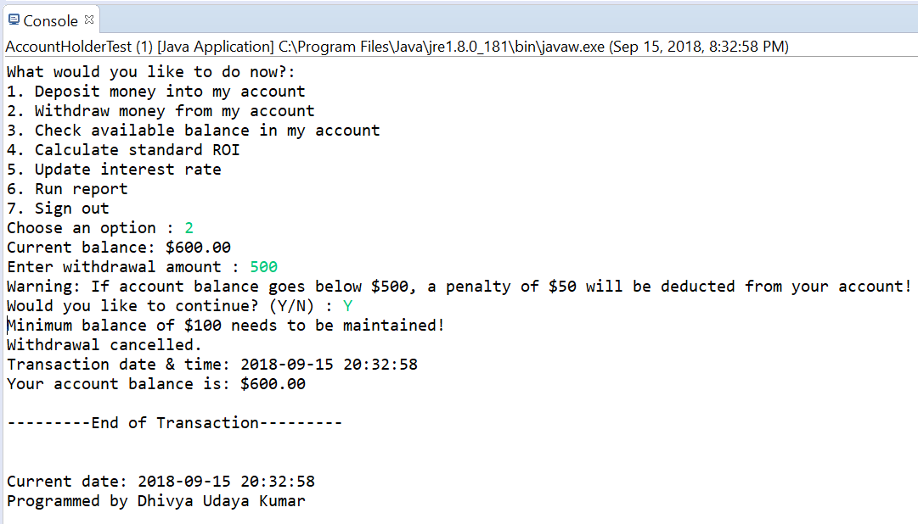

1. Prompt user to withdraw (Successful withdrawal scenario - with penalty deduction for Account balance below $500)

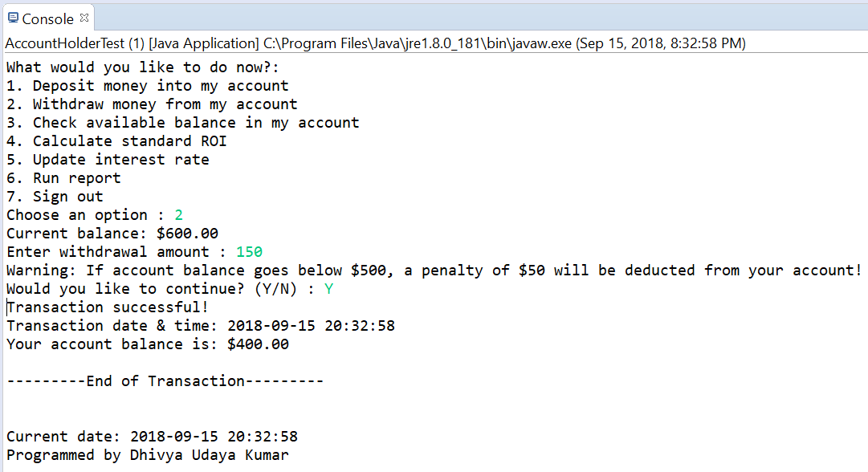

1. Prompt user to check available balance in account

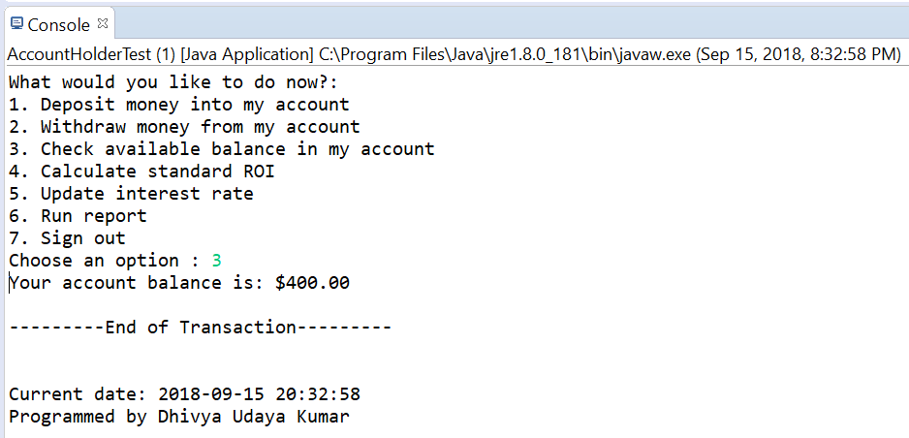

1. Prompt user to determine ROI for a requested period of months

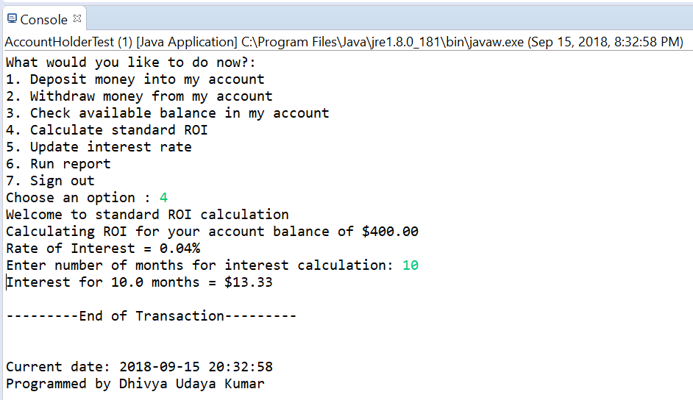

1. Run a report of account balance at end of each month for given interest rate and period of months

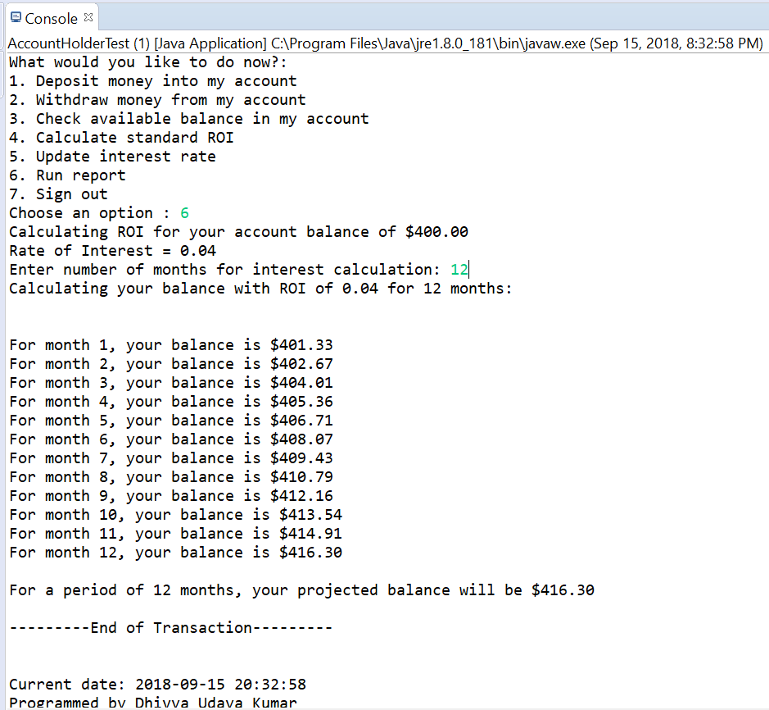

1. Prompt user to update ROI and calculate balance for new ROI

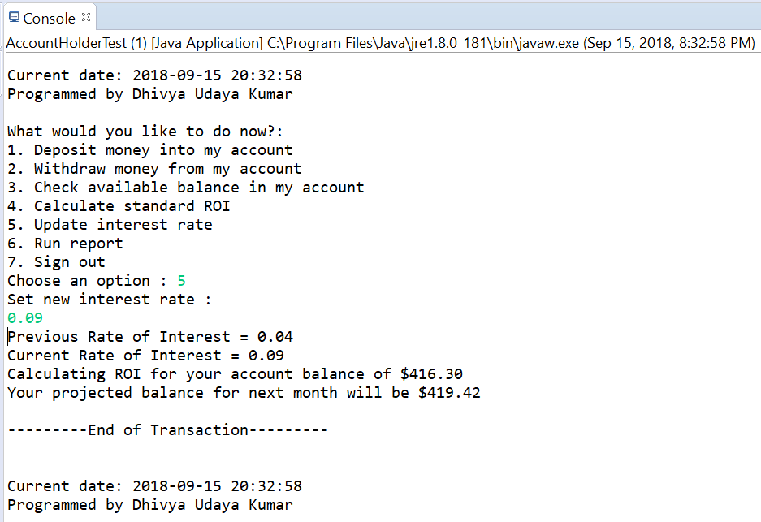

1. Prompt user to sign out of account

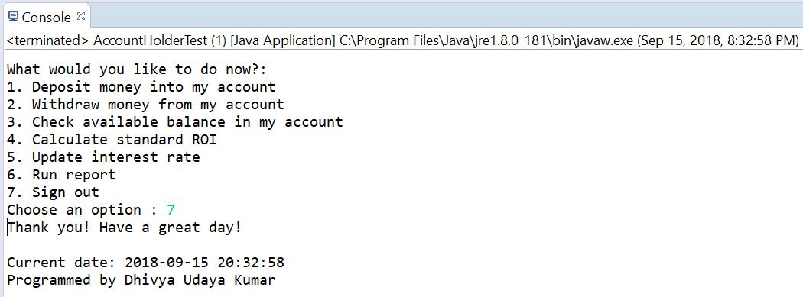

**Source code**:

1. **AccountHolder.java**

/*

* Class name: AccountHolder

* Description: Class contains methods for various bank operations

* Programmed by: Dhivya Udaya Kumar

* CWID: A20432502

* Date: 15-Sep-2018

* Lab number: 01

*/

import java.util.Objects;

import java.util.Scanner;

public class AccountHolder {

//Current account balance

private double balance=0;

//Default interest rate

private static double annualInterestRate = 0.04;

/*

* Method name: main

* Description: Main method of the class; Execution begins here

* Arguments: String

* Return type: void

*/

public static void main(String[] args) {

//Object creation

AccountHolder accBalance = new AccountHolder(1000);

}

/*

* Constructor: AccountHolder

* Description: Creates new account with user specified balance

* Arguments: double

*/

public AccountHolder(double balance) {

if(balance < 0) {

//Error trapping for negative input by user

System.out.println("Please enter a positive value");

}

else {

this.balance = balance;

}

}

/*

* Method name: deposit

* Description: Method adds amount deposited by user to existing balance

* Arguments: double

* Return type: void

*/

public void deposit(double depositAmount) {

this.balance = this.balance + depositAmount;

}

/*

* Method name: withdrawal

* Description: Method subtracts amount withdrawn by user from existing balance

* Arguments: double

* Return type: void

*/

public void withdrawal(double withdrawAmount) {

if(this.balance - withdrawAmount < 500) {

Scanner sc = new Scanner(System.in);

String response;

System.out.println("Warning: If account balance goes below $500, a penalty of $50 will be deducted from your account!");

System.out.print("Would you like to continue? (Y/N) : ");

response = sc.nextLine();

if(this.balance - withdrawAmount - 50 < 100 && (Objects.equals(response, "y") || Objects.equals(response, "Y"))) {

System.out.println("Minimum balance of $100 needs to be maintained!");

System.out.println("Withdrawal cancelled.");

}

else if (Objects.equals(response, "y") || Objects.equals(response, "Y")){

this.balance = this.balance - withdrawAmount - 50;

System.out.println("Transaction successful!");

}

else if (Objects.equals(response, "n") || Objects.equals(response, "N")){

System.out.println("Withdrawal cancelled.");

}

}

else {

this.balance = this.balance - withdrawAmount;

System.out.println("Transaction successful!");

}

}

/*

* Method name: getAnnualInterestRate

* Description: Getter method for fetching current interest rate

* Arguments: None

* Return type: double

*/

public double getAnnualInterestRate() {

return annualInterestRate;

}

/*

* Method name: monthlyInterest

* Description: Method updates existing balance with the addition of annual interest

* Arguments: None

* Return type: void

*/

public void monthlyInterest() {

balance += balance * (annualInterestRate / 12.0);

}

/*

* Method name: roi

* Description: Method to calculate standard ROI for given number of months

* Arguments: double

* Return type: double

*/

public double roi(double numOfMonths) {

return balance * numOfMonths * (annualInterestRate / 12.0);

}

/*

* Method name: modifyMonthlyInterest

* Description: Method updates annual interest rate with new rate

* Arguments: double

* Return type: void

*/

public static void modifyMonthlyInterest(double rateUpdate) {

if((rateUpdate > 0.01) && (rateUpdate < 1.00)) {

annualInterestRate = rateUpdate;

}

else {

System.out.println("Please enter interest rate in decimal ranging (0.01 - 1.00)");

}

}

/*

* Method name: toString

* Description: Method converts the balance amount to user-friendly format

* Arguments: None

* Return type: String

*/

public String toString() {

return String.format("$%.2f", balance);

}

}

1. **AccountHolderTest.java**

/*

* Class name: AccountHolderTest

* Description: Test class to test every scenario of bank operations

* Programmed by: Dhivya Udaya Kumar

* CWID: A20432502

* Date: 15-Sep-2018

* Lab number: 01

*/

import java.time.LocalDateTime;

import java.time.format.DateTimeFormatter;

import java.util.Scanner;

public class AccountHolderTest {//class-S

public static void main(String[] args) {//main-S

/*

* Declaring initial variables

*/

Scanner sc = new Scanner(System.in);

Double userResponse = 0.0;

Integer numOfMonths = 0;

Integer userSelection = 0;

Integer userSetPin = 0000;

/*

* Initializing account-holder object

*/

AccountHolder ahObj = null;

/*

* Setting up welcome message, date and time

*/

LocalDateTime locDateTime = LocalDateTime.now();

DateTimeFormatter formatter = DateTimeFormatter.ofPattern("yyyy-MM-dd HH:mm:ss");

String formatDateTime = locDateTime.format(formatter);

System.out.println("Current date: "+ formatDateTime);

System.out.println("Programmed by Dhivya Udaya Kumar \n");

System.out.println("Welcome to Bank of Illinois Institute of Technology, Chicago \n");

/*

* Logic to accept initial deposit to start user's account

*/

do {//DW1-S

System.out.println("Please choose the following options to proceed");

System.out.print("Enter 1 for initial deposit: ");

if(sc.hasNextInt()) {

userSelection = sc.nextInt();

}

else {

sc.next();

}

if(userSelection != 1) {

System.out.println("Please choose a valid number! \n");

}

}while(userSelection != 1);//DW1-E

do {//DW2-S

System.out.println();

System.out.print("Enter the amount you wish to deposit : ");

if(sc.hasNextDouble()) {

userResponse = sc.nextDouble();

}

else {

sc.next();

}

if(userResponse > 0) {

ahObj = new AccountHolder(userResponse);

System.out.println("Transaction successful!");

System.out.println("Transaction date & time: "+formatDateTime);

System.out.println("Your account balance is: "+ahObj.toString() +"\n\n");

System.out.println("---------End of Transaction---------");

}

else {//handling case where initial deposit is <= $0 or not a valid number

System.out.println("Invalid amount entered! Please enter a valid amount!");

}

}while(userResponse <= 0);//DW2-E

/*

*Menu Entry for user

*/

do {//DW3-S

System.out.println("What would you like to do now?: ");

System.out.println("1. Deposit money into my account");

System.out.println("2. Withdraw money from my account");

System.out.println("3. Check available balance in my account");

System.out.println("4. Calculate standard ROI");

System.out.println("5. Update interest rate");

System.out.println("6. Run report");

System.out.println("7. Sign out");

do {//DW4-S

System.out.print("Choose an option : ");

if(sc.hasNextInt()) {

userSelection = sc.nextInt();

}

else {

sc.next();

}

if(userSelection < 1 || userSelection > 7) {//if-S

System.out.println("Invalid! Please enter a valid number! \n");

}//if-E

}while(userSelection <=1 && userSelection >= 7);//DW4-E

switch(userSelection) {//switch-S

case 1:

{//c1-S

/*

* Testing deposit addition scenario

*/

System.out.print("Enter deposit amount : ");

userResponse = sc.nextDouble();

//Add deposit to existing balance in user's account

ahObj.deposit(userResponse);

System.out.println("Transaction successful!");

System.out.println("Transaction date & time: "+formatDateTime);

System.out.println("Your account balance is: "+ahObj.toString() +"\n");

System.out.println("---------End of Transaction---------");

System.out.println();

System.out.println("Current date: "+ formatDateTime);

System.out.println("Programmed by Dhivya Udaya Kumar \n");

break;

}//c1-E

case 2:

{//c2-S

/*

* Testing withdrawal deduction scenario

*/

System.out.println("Current balance: "+ahObj.toString());

System.out.print("Enter withdrawal amount : ");

userResponse = sc.nextDouble();

//Deduct amount from existing balance in user's account

ahObj.withdrawal(userResponse);

System.out.println("Transaction date & time: "+formatDateTime);

System.out.println("Your account balance is: "+ahObj.toString() +"\n");

System.out.println("---------End of Transaction--------- \n");

System.out.println();

System.out.println("Current date: "+ formatDateTime);

System.out.println("Programmed by Dhivya Udaya Kumar \n");

break;

}//c2-E

case 3:

{//c3-S

/*

* Testing balance check scenario

*/

System.out.println("Your account balance is: "+ahObj.toString() +"\n");

System.out.println("---------End of Transaction--------- \n");

System.out.println();

System.out.println("Current date: "+ formatDateTime);

System.out.println("Programmed by Dhivya Udaya Kumar \n");

break;

}//c3-E

case 4:

{//c4-S

/*

* Calculate standard ROI

*/

do {

System.out.println("Welcome to standard ROI calculation");

System.out.println("Calculating ROI for your account balance of "+ahObj.toString());

System.out.println("Rate of Interest = "+ ahObj.getAnnualInterestRate()+"%");

System.out.print("Enter number of months for interest calculation: ");

userResponse = sc.nextDouble();

if(userResponse <= 0) {

System.out.println("Invalid entry. Please enter valid value.");

System.out.println();

System.out.println("Current date: "+ formatDateTime);

System.out.println("Programmed by Dhivya Udaya Kumar \n");

}

else {

System.out.println("Interest for " + userResponse + " months = $" + String.format("%.2f", ahObj.roi(userResponse)) +"\n");

System.out.println("---------End of Transaction--------- \n");

System.out.println();

System.out.println("Current date: "+ formatDateTime);

System.out.println("Programmed by Dhivya Udaya Kumar \n");

}

}while(userResponse <= 0);

break;

}//c4-E

case 5:

{//c5-S

/*

* Set new Interest rate

*/

System.out.println("Set new interest rate : ");

userResponse = sc.nextDouble();

System.out.println("Previous Rate of Interest = "+ahObj.getAnnualInterestRate());

AccountHolder.modifyMonthlyInterest(userResponse);

System.out.println("Current Rate of Interest = "+ahObj.getAnnualInterestRate());

System.out.println("Calculating ROI for your account balance of "+ahObj.toString());

ahObj.monthlyInterest();

System.out.println("Your projected balance for next month will be "+ahObj.toString() +"\n");

System.out.println("---------End of Transaction--------- \n");

System.out.println();

System.out.println("Current date: "+ formatDateTime);

System.out.println("Programmed by Dhivya Udaya Kumar \n");

break;

}//c5-E

case 6:

{//c6-S

/*

* Run Report

*/

do {

System.out.println("Calculating ROI for your account balance of "+ahObj.toString());

System.out.println("Rate of Interest = "+ ahObj.getAnnualInterestRate());

System.out.print("Enter number of months for interest calculation: ");

numOfMonths = sc.nextInt();

if(userResponse <= 0) {

System.out.println("Invalid entry. Please enter valid value.");

}

else {

System.out.println("Calculating your balance with ROI of " + ahObj.getAnnualInterestRate() + " for " + numOfMonths + " months:");

System.out.println("\n");

for(int i=1; i<= numOfMonths ; i++) {

ahObj.monthlyInterest();

System.out.println("For month " + i + ", your balance is "+ ahObj.toString());

}

System.out.println();

System.out.println("For a period of " + numOfMonths + " months, your projected balance will be "+ ahObj.toString()+ "\n");

System.out.println("---------End of Transaction--------- \n");

System.out.println();

System.out.println("Current date: "+ formatDateTime);

System.out.println("Programmed by Dhivya Udaya Kumar \n");

}

}while(userResponse <= 0);

break;

}//c6-E

case 7:

{//c7-S

/*

* Sign out of the user's account

*/

System.out.println("Thank you! Have a great day!");

System.out.println();

System.out.println("Current date: "+ formatDateTime);

System.out.println("Programmed by Dhivya Udaya Kumar \n");

break;

}//c7-E

}//switch-E

}while(userSelection != 7);//DW1-E

}//main-E

}//class-E